EARTH DAY BOOKLIST 2021
https://www.anokacounty.us/1758/Libraries

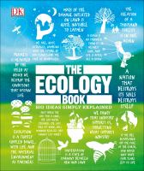
The Ecology Book
“Using a bold, graphic-led approach, The Ecology Book explores and explains over 85 of the key ideas, movements, and acts that have defined ecology and ecological thought.” (2019)

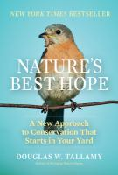
Nature's best hope: a new approach to conservation that starts in your yard
by Douglas W. Tallamy
“Nature's Best Hope shows how homeowners everywhere can turn their yards into conservation corridors that provide wildlife habitats.” (2019)

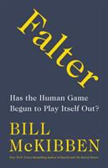
Falter: has the human game begun to play itself out? by Bill McKibben
“Thirty years ago, Bill McKibben offered one of the earliest warnings about climate change. Now he broadens the warning: the entire human game, he suggests, has begun to play itself out.” (2019)

EARTH DAY BOOKLIST 2021
https://www.anokacounty.us/1758/Libraries

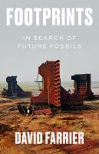
Footprints: in search of future fossils by David Farrier
“Crossing the boundaries of literature, art, and science, Footprints invites us to think about how we will be remembered in the myths and stories of our distant descendants.” (2020)

The fragile earth: writing from the New Yorker on climate change
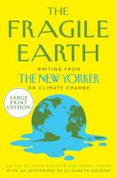
"A collection of the New Yorker's groundbreaking reporting from the front lines of climate change” (2020)

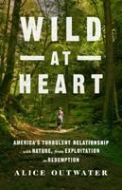
Wild at heart: America's turbulent relationship with nature, from exploitation to redemption by Alice Outwater
“In a narrative that reaches from Native American tribal practices to public health and commercial hunting, Wild at Heart shows how western attitudes towards nature have changed dramatically in the last five hundred years.” (2019)

EARTH DAY BOOKLIST 2021
https://www.anokacounty.us/1758/Libraries

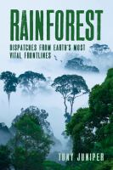
Rainforest: dispatches from earth's most vital frontlines by Tony Juniper
In “Rainforest: Dispatches from Earth's Most Vital Frontlines” a prominent conservationist provides a comprehensive view of the crucial roles rainforests serve, the state of the world's rainforests today, and the inspirational efforts underway to save them. (2019)

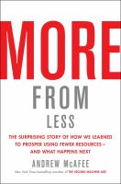
More from less: the surprising story of how we learned to prosper using fewer resources--and what happens next by Andrew McAfee
"A surprising analysis of the decline in consumption of natural resources despite the explosion of goods, prosperity, and population" (2019)

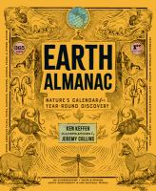
Earth almanac: nature's calendar for year-round discovery by Ken Keffer
“Beginning with the Winter Solstice in December, Earth Almanac highlights a wide range of natural history, including mammals, birds, fish, reptiles, insects, intertidal and marine life, trees, plants, fungi, environmental activists, and more, all the while revealing the ebb and flow of nature across the planet.” (2020)

Superman's not coming: our national water crisis and what we the people can do about it by Erin Brockovich
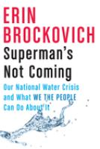
“Superman Isn't Coming makes clear that the most precious resource on planet Earth is alarmingly polluted by toxins, hazardous waste, lead, fracking chemicals, and more.” (2020)
All descriptions taken from Anoka County Library catalog or Novelist 2021

