Books to Celebrate Earth Day
https://www.anokacounty.us/1758/Libraries
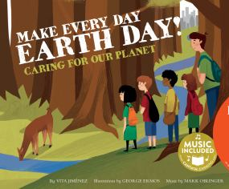
Make Every Day Earth Day! Caring for our Planet, Vita Jimenez
In this catchy song paired with colorful illustrations, children learn how to care for our planet. 2017.

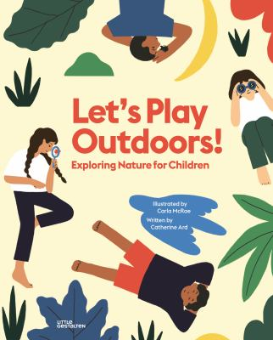
Let’s Play Outdoors! Exploring Nature for Children; Catherine Ard, ill. Carla McRae
A book that encourages children to go and play outside and discover what nature has to offer. 2020.

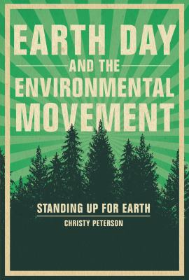
Earth Day and the Environmental Movement: Standing Up for the Earth, Christy Peterson
A historical look at the launch of Earth Day and a look at the global environmental movement that has sprung from it. 2020.

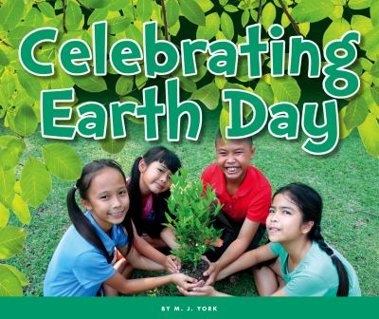
Celebrating Earth Day, M. J. York
Engage readers with a story of celebrating Earth Day. Readers are introduced to Earth Day activities, such as planting trees or cleaning up litter. 2017.

Books to Celebrate Earth Day
https://www.anokacounty.us/1758/Libraries
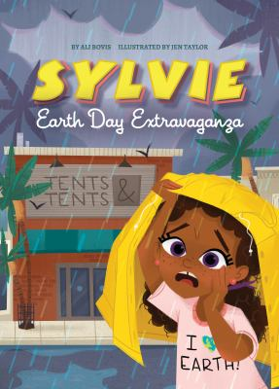
Earth Day Extravaganza, Ali Bovis
Sylvie's excitement for the upcoming Earth Day Extravaganza fizzles when her cousin, the non-recycler, visits, and she worries not only about saving the entire world, but also about saving the Extravaganza itself. 2020.

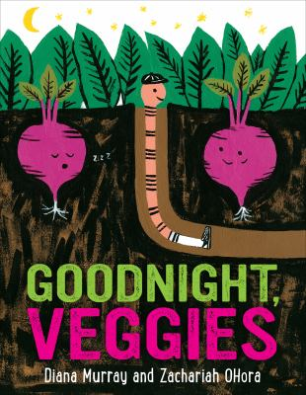
Good Night Veggies, Diana Murray, ill: Zachariah OHora
Illustrations and easy-to-read, rhyming text invite the reader to a community garden where potatoes close their eyes, cabbages nod their heads, and corn covers its ears to go to sleep. 2020.

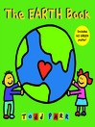

The Earth Book, Todd Parr
Simple text and illustrations show how children can help protect the Earth. 2010.

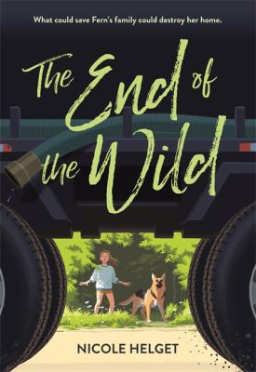
The End of the Wild, Nicole Helget
Eleven-year-old Fern helps to take care of her impoverished family by foraging for food in the forest, but when a fracking company rolls into town, she realizes that her peaceful woods and her family's livelihood could be threatened.

